# Activate the virtual environment every time you start a new command prompt

<https://docs.djangoproject.com/en/3.1/howto/windows/>

* Open command prompt using the administrator permission
* Navigate before project name
* py -m venv project-name
* level4-project\Scripts\activiate.bat

# Programming Languages

<https://stackshare.io/instagram/instagram>

Don’t use react native because there are too many iPhone and Android Interaction

Use react because you just want a web

Visual Studio code because linkedIn Learning are based on this platform

Django - PostgreSQL – complex queries

React over Javascript (easier, more maintainable, popular)

* fire blade plugin to convert adobe xd code to react code
* don’t think about react native’s cross platform between mobile web and mobile app (Android & iOS) because you will need far more time to code the project

Graph QL for data loading

not jQuery because a performance killer

<https://ironeko.com/posts/jquery-alternatives-in-2020-do-you-really-need-it>

Anime.js

* deals with web animation

https://animejs.com/documentation/#timelineBasics

NGINX

Visual studio code because you need to pay for pycharm professional

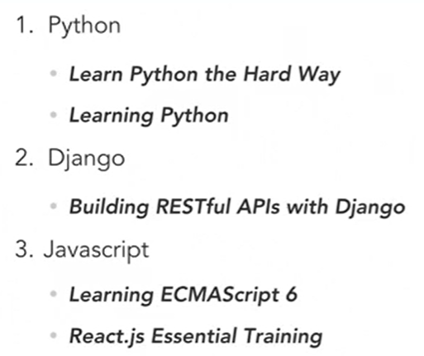

# Programming Strategy

React and Django code are linked together via separate files calling each other through an API

* Set up project
* Go through basic react tutorials until you get a grasp and code something
* Auto-generate react front-end code using fire blade (for first page)
* Launch the web
* Go through basic PostgreSQL database tutorials to set up the database
* Set up database (for one database)
* Set up web display based on database – update data with front-end interaction
* Go through responsive design with react and code that
* Test suites for react, auto-generate test cases using test coverage – refer to the bookmark web link
* Start the coding process - prioritise and execute the development (restaurant owner page & customer > staff > chef/ waiter page > CEO page)